AKS Release Pipeline

Pre-requisite 🡪 Add Artifacts

1.Create Secret (A)

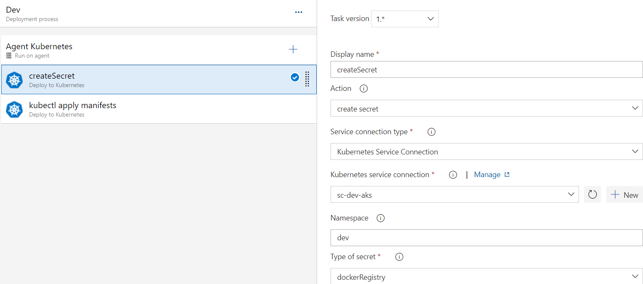

1.Create Secret (B)

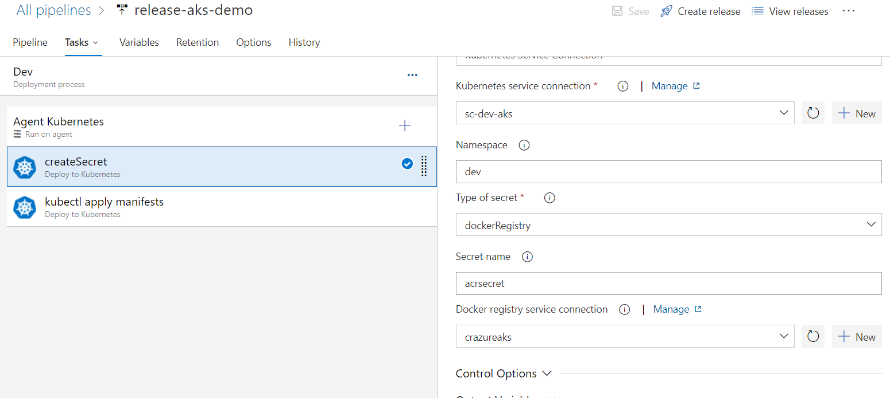

2.Kubectl apply Manifest (A)

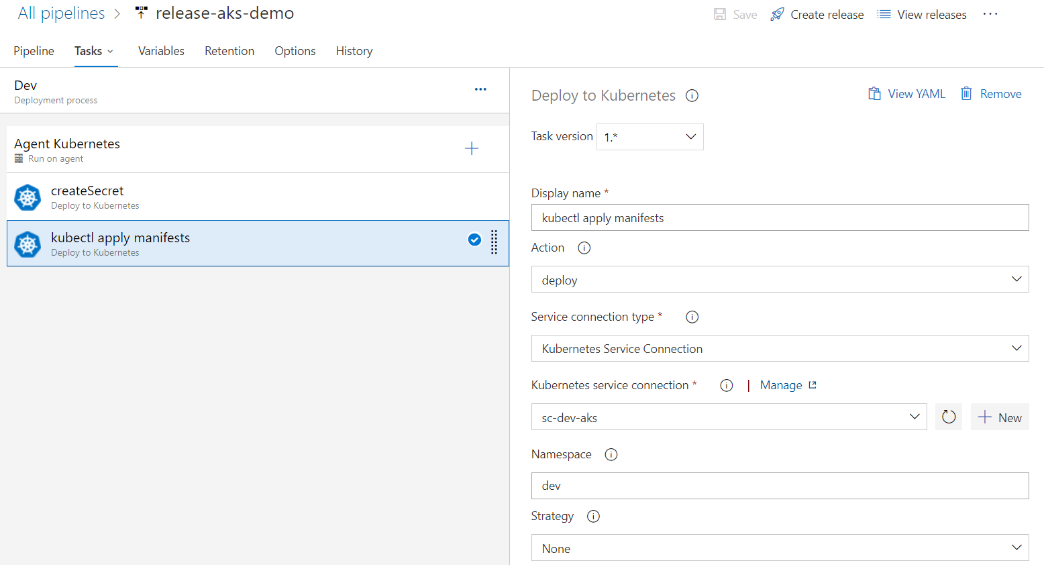

2.Kubectl apply Manifest (B)

